MongoDB_Lab1

Name: Karim Ali Ramadan Ali
Track : Professional Web Development & BI ( Intake 43 ) – Alex Branch - ITI
1 – open mongo shell and view the help

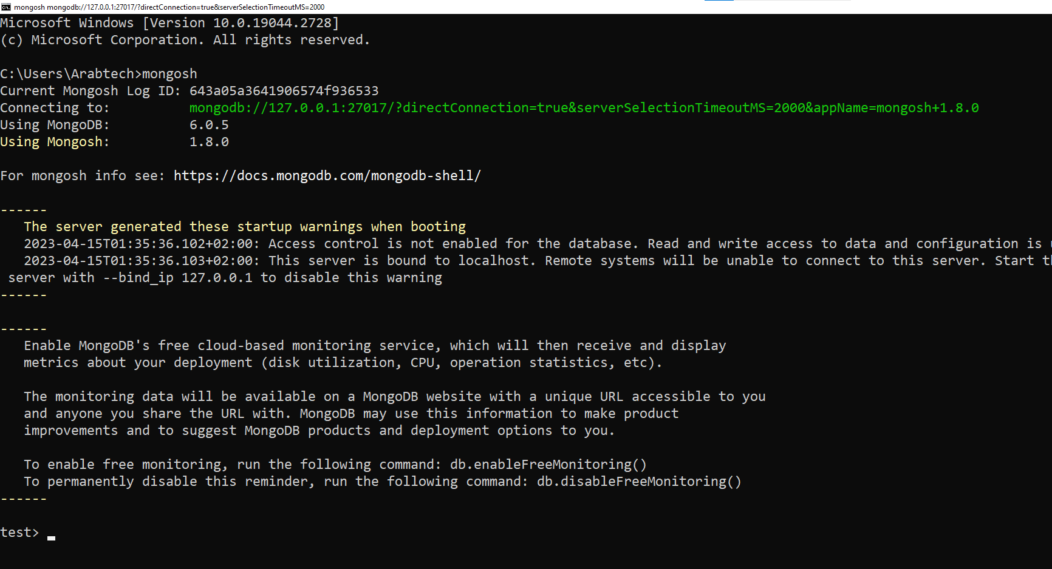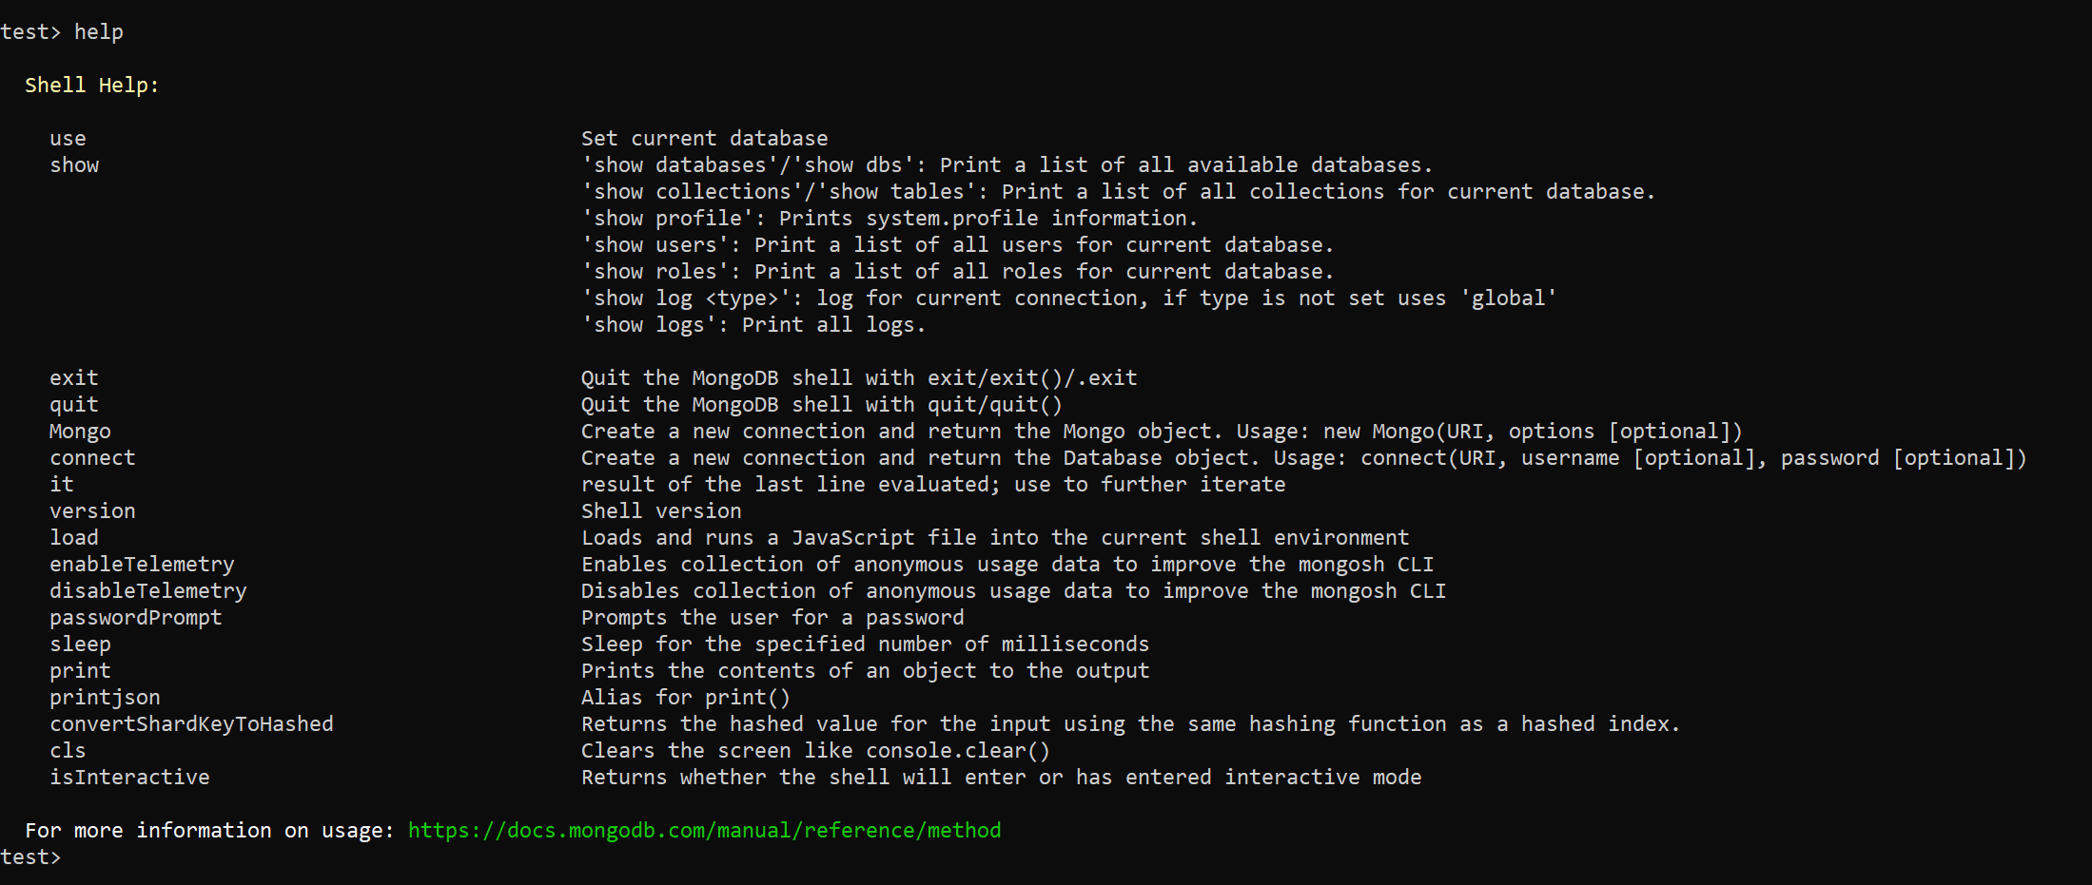

2 – identify your current working database and show list of available databases

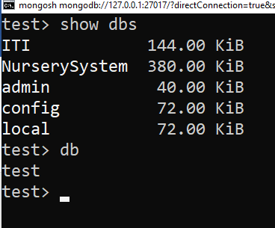
3 – create a new database called iti and create a collection named “students”. Insert whatever data you want about yourself (include name and age in your details).
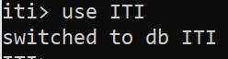

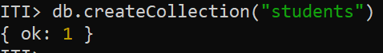

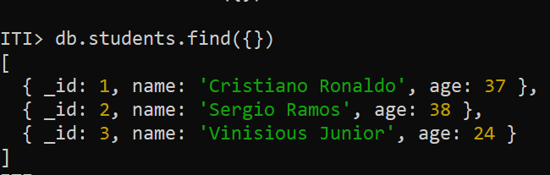
4– show list of available databases. What did you notice?

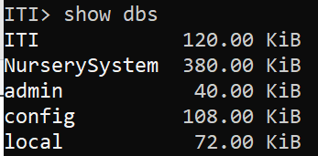

Database ITI added

5 – Insert un-structured or semi-structured data for 10 of your friends (include name and age in your details. The documents should have different types of data i.e. arrays, strings, documents, integers).

db.students.insertMany( [
{_id:4,name:"Karim Ali",age:26},
{_id:5,name:"Mohamed Ahmed",age:26},
{_id:6,name:"Hesham Abden",age:25},
{_id:7,name:"Ahmed Hassanin",age:23},
{_id:8,name:"Mohamed Moustafa",age:24}
] )

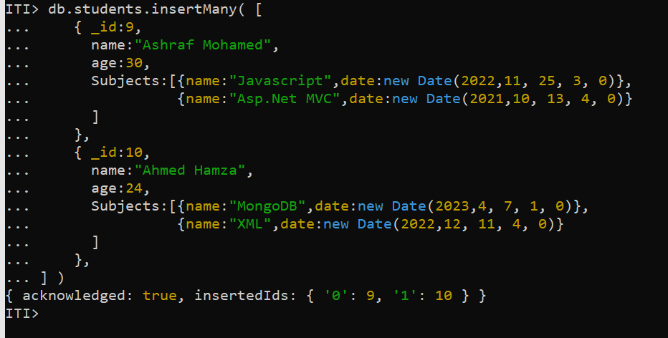

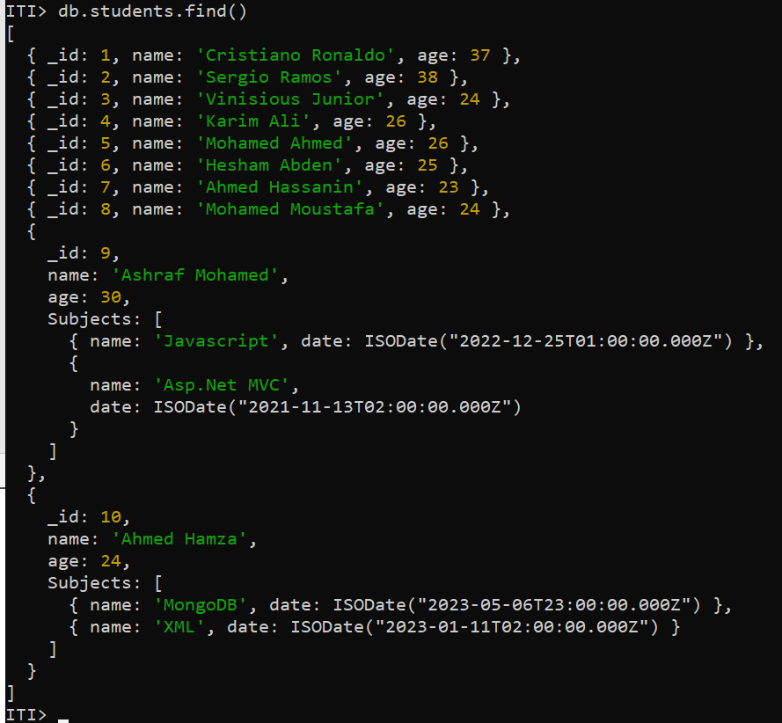

6 – Search for your object by name.
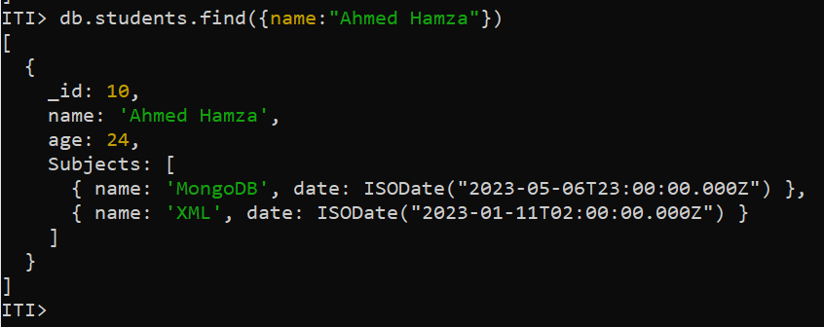
7– Search for your friend(s) by age.
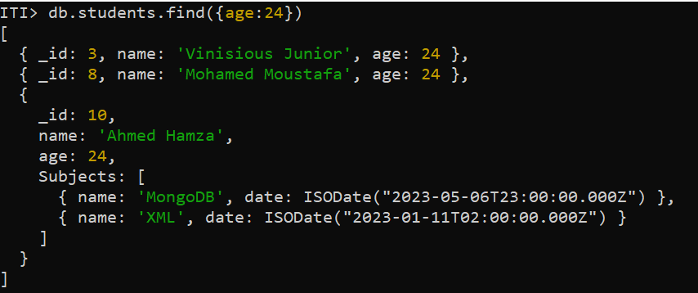

8 – Search for all of your friends whose age is older than yours.
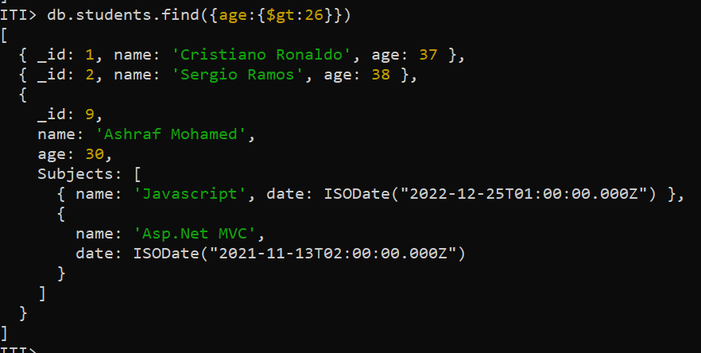

9 – delete any of your friends by id.
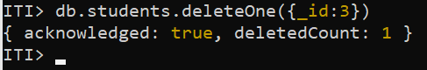

10 – view all documents in students’ collection in a prettified format.
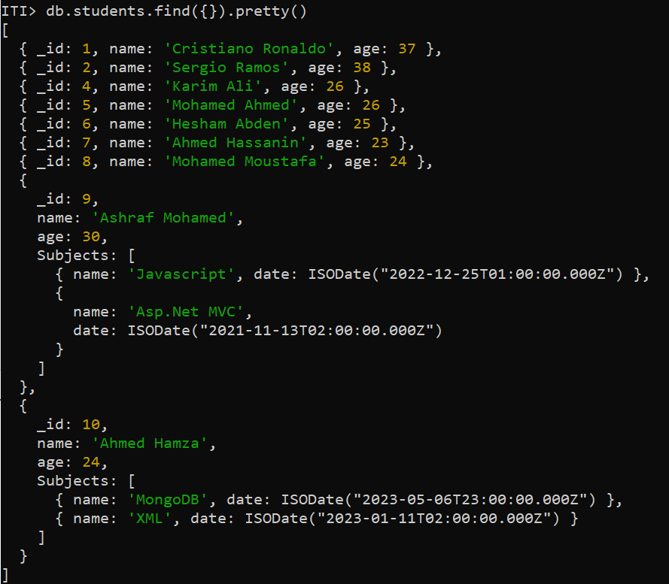
11 – count all documents in students’ collection.
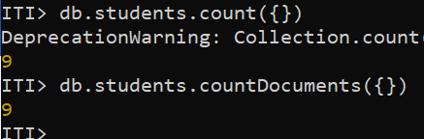
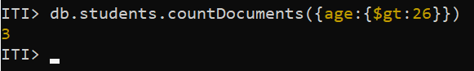

part 2

- Create database with name ems

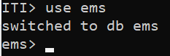
2- Insert the following data into "faculty" collection
{ "name":"Krish", "age":35,"gender":"M","exp":10,subjects:["DS","C","OS"],"type":"Full Time","qualification":"M.Tech" },
{ "name":"Manoj", "age":38,"gender":"M","exp":12,subjects:["JAVA","DBMS"],"type":"Full Time", "qualification":"Ph.D"},
{ "name":"Anush", "age":32,"gender":"F","exp":8,subjects:["C","CPP"],"type":"Part Time","qualification":"M.Tech" },
{ "name":"Suresh", "age":40,"gender":"M","exp":9,subjects:["JAVA","DBMS","NETWORKING"],"type":"Full Time", "qualification":"Ph.D"},
{ "name":"Rajesh", "age":35,"gender":"M","exp":7,subjects:["DS","C","OS"],"type":"Full Time","qualification":"M.Tech" },
{ "name":"Mani", "age":38,"gender":"F","exp":10,subjects:["JAVA","DBMS","OS"],"type":"Part Time", "qualification":"Ph.D"},
{ "name":"Sivani", "age":32,"gender":"F","exp":8,subjects:["C","CPP","MATHS"],"type":"Part Time","qualification":"M.Tech" },
{ "name":"Nagesh", "age":39,"gender":"M","exp":11,subjects:["JAVA","DBMS","NETWORKING"],"type":"Full Time", "qualification":"Ph.D"},
{ "name":"Nagesh", "age":35,"gender":"M","exp":9,subjects:["JAVA",".Net","NETWORKING"],"type":"Full Time", "qualification":"Ph.D"},
{ "name":"Latha", "age":40,"gender":"F","exp":13,subjects:["MATHS"],"type":"Full Time", "qualification":"Ph.D"}
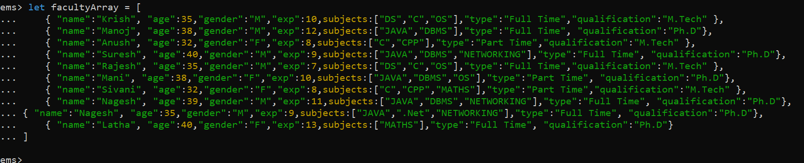
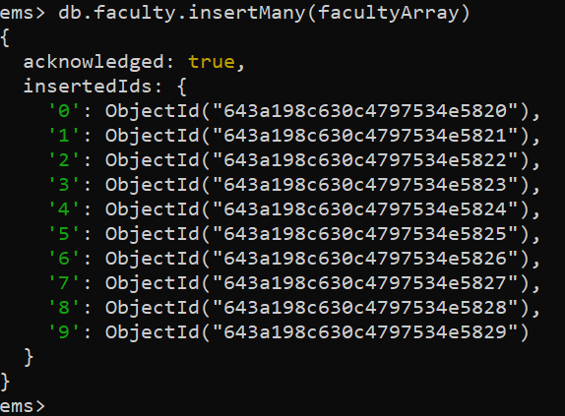
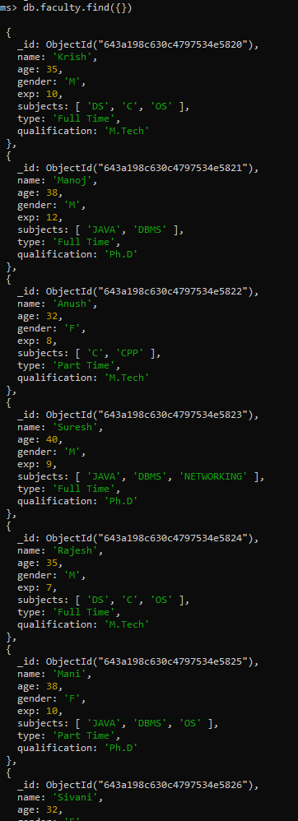
- Get the details of all the faculty.

2. Get the count of all faculty members.
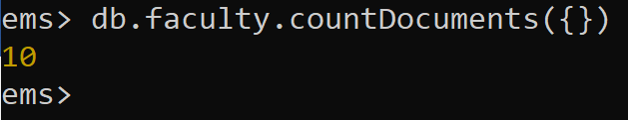

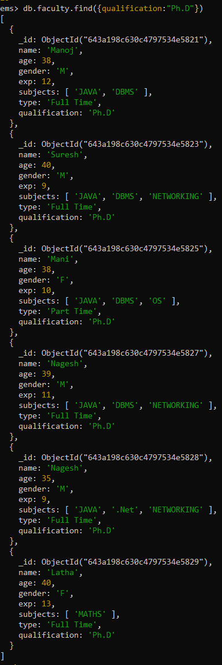
3.Get all the faculty members whose qualification is “Ph.D”.

4.Get all the faculty members whose experience is between 8 to 12 years.
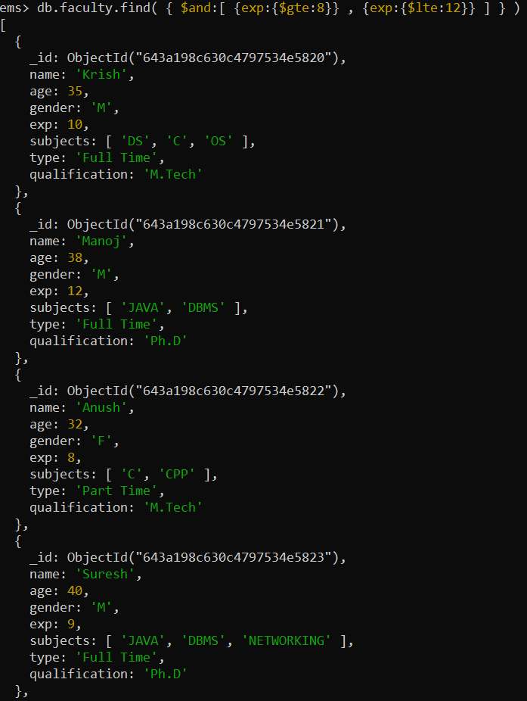
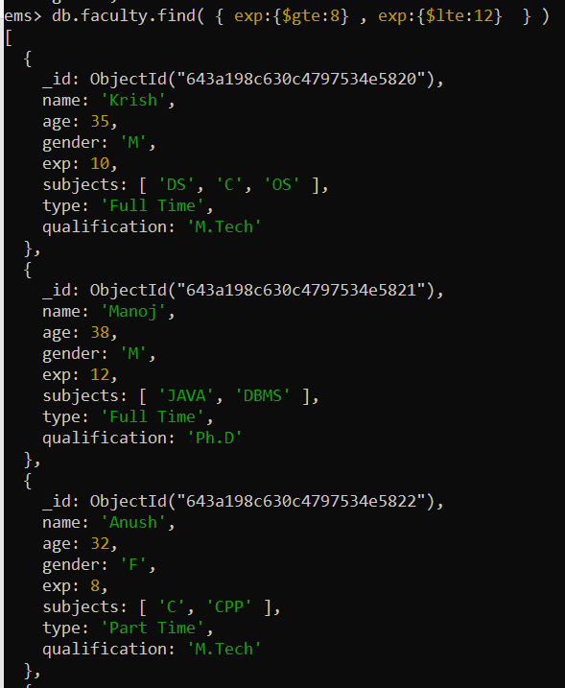

5.Get all the faculty members who teach “MATHS” or “NETWORKING”.
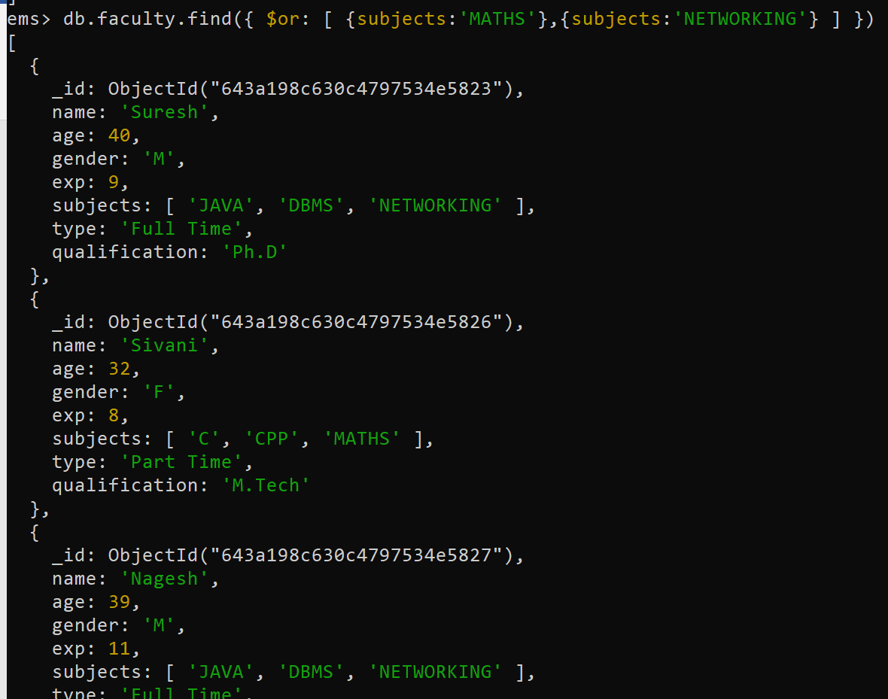

6.Get all the faculty members who teach “MATHS” and whose age is more than 30 years and qualification must be “Ph.D”.
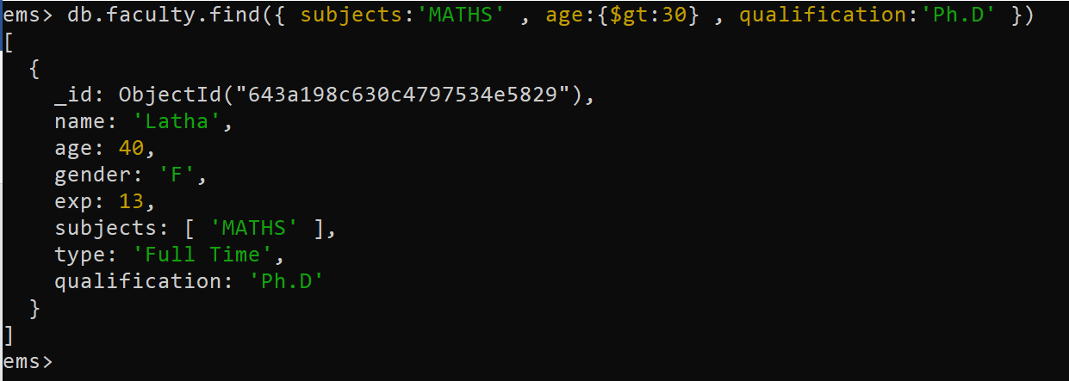

7.Get all the faculty members who are working part-time or who teach “JAVA”.
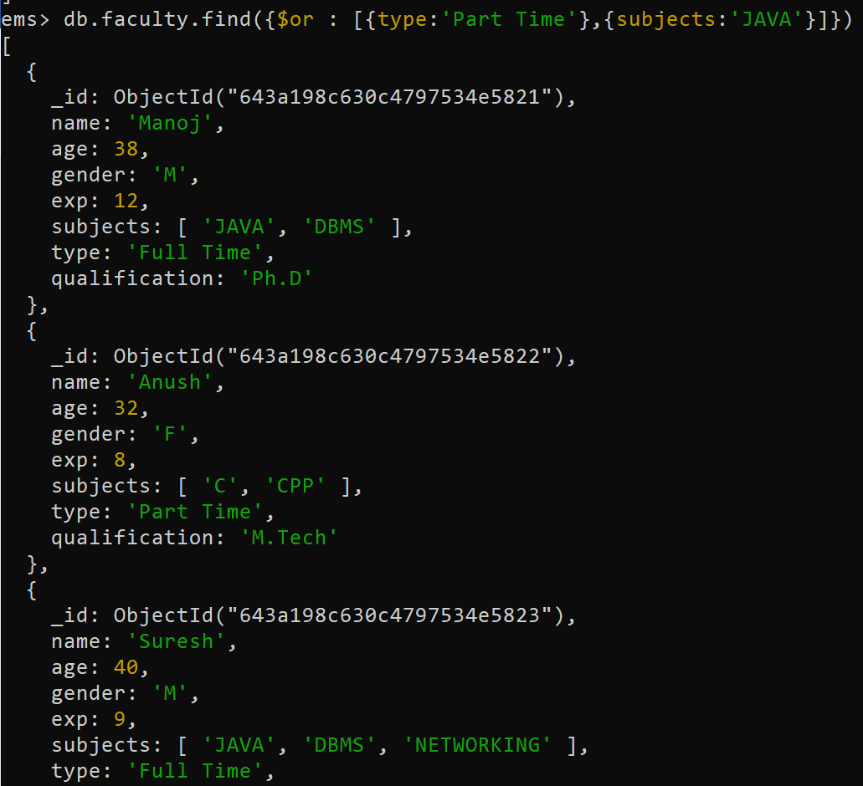

8. Add the following new faculty members:
{ "name":"Suresh Babu", "age":55,"gender":"M","exp":25,subjects: ["MATHS","DE"],"type":"Full Time", "qualification":"Ph.D"}

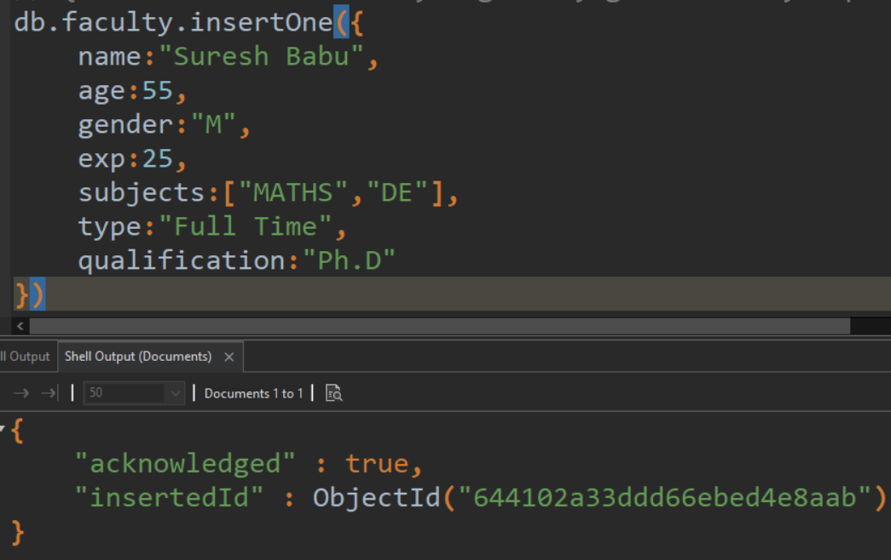

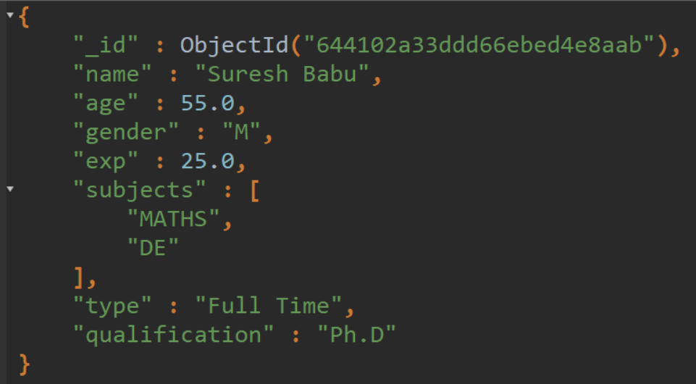

9. Update the data of all faculty members by incrementing their age and exp by one year.
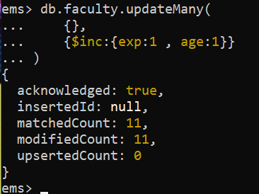

10. Update the faculty “Sivani” with the following data: update qualification to “Ph.D” and type to “Full Time”.
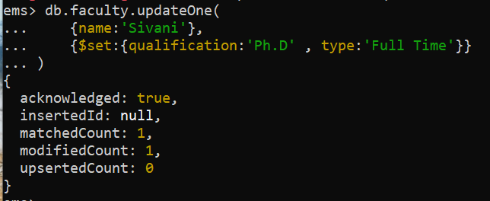
11. Update all faculty members who are teaching “MATHS” such that they should now also teach “PSK”.
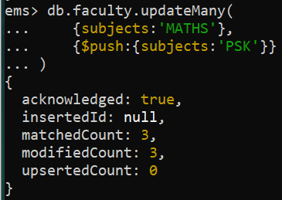

12. Delete all faculty members whose age is more than 55 years.
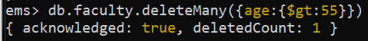

13. Get only the name and qualification of all faculty members.

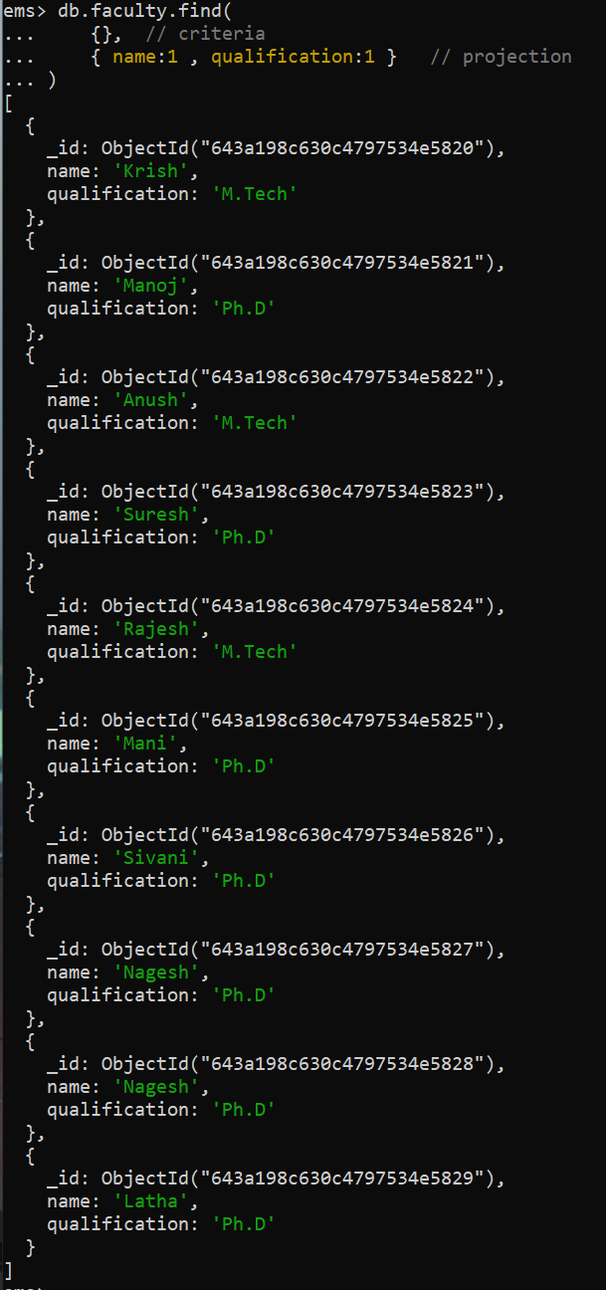
14. Get the name, qualification and exp of all faculty members and display the same in ascending order of exp.
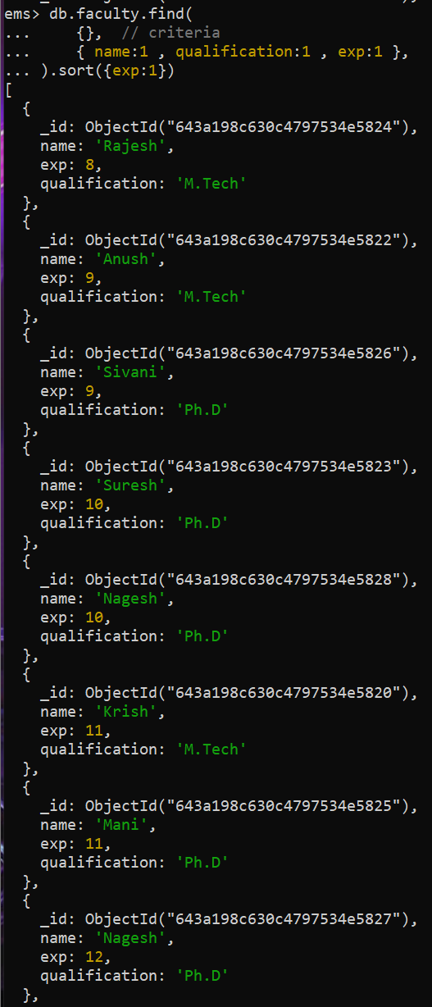

15. Sort the faculty details by their age (descending order) and get the details of the first five faculty members only.
